Table of Contents
1 Adapter Pattern 1
1.1 Class Adapters - Based on (Multiple) Inheritance 1
1.2 Object Adapters 1

Observer pattern
Observer pattern is used for observing some objects. Observer watches for any change in state or property of subject. Suppose you are interested in particular object and want to get notified when its state changes then you observe that object and when any state or property change happens to that object, it get notified to you.

Adapter Pattern
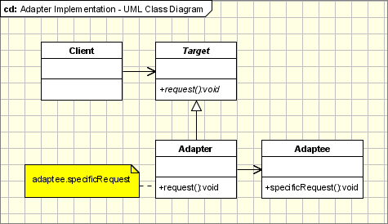

Class Adapters - Based on (Multiple) Inheritance
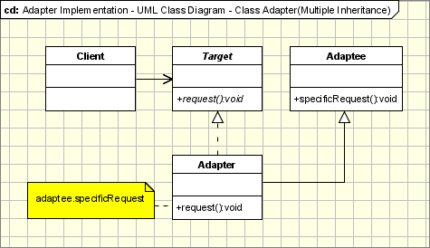

Object Adapters

